|  |  |  |  |  |  |  |  |
| --- | --- | --- | --- | --- | --- | --- | --- |
|  | | | | | | | |
| Prediction using Unsupervised learning  **In [2]: import numpy as np**  **import matplotlib.pyplot as plt import pandas as pd**  **import seaborn as sns**  **from sklearn import datasets**  Loading Data set  **In [3]: # Load the iris dataset**  **df = pd.read_csv('Iris.csv') df.head()**  **Out [3]:**  Id SepalLengthCm SepalWidthCm PetalLengthCm PetalWidthCm Species | | | | | | | |
|  | 0 | 1 | 5.1 | 3.5 | 1.4 | 0.2 | Iris- setosa |
|  | 1 | 2 | 4.9 | 3.0 | 1.4 | 0.2 | Iris- setosa |
|  | 2 | 3 | 4.7 | 3.2 | 1.3 | 0.2 | Iris- setosa |
|  | 3 | 4 | 4.6 | 3.1 | 1.5 | 0.2 | Iris- setosa |
|  | 4 | 5 | 5.0 | 3.6 | 1.4 | 0.2 | Iris- setosa |
| **In [4]: df.info()**  **<class 'pandas.core.frame.DataFrame'> RangeIndex: 150 entries, 0 to 149 Data columns (total 6 columns):**  **# Column Non-Null Count Dtype**     1. **Id 150 non-null int64** 2. **SepalLengthCm 150 non-null float64** 3. **SepalWidthCm 150 non-null float64** 4. **PetalLengthCm 150 non-null float64** 5. **PetalWidthCm 150 non-null float64** 6. **Species 150 non-null object dtypes: float64(4), int64(1), object(1) memory usage: 7.2+ KB**   **In [5]: df.isnull().sum()** | | | | | | | |

Out [5]: Id 0

SepalLengthCm 0

SepalWidthCm 0

PetalLengthCm 0

PetalWidthCm 0

Species 0

dtype: int64

In [6]:

**=**

Out [6]:

SepalLengthCm SepalWidthCm PetalLengthCm PetalWidthCm Species

1 4.9 3.0 1.4 0.2

Iris- setosa

3 4.6 3.1 1.5 0.2

Iris- setosa

**df**

**df.drop(columns= ['Id'])**

**df.head()**

0 5.1

3.5

1.4

0.2

Iris-

setosa

2 4.7

3.2

1.3

0.2

Iris-

setosa

4 5.0

3.6

1.4

0.2

Iris-

setosa

In [7]:

**df.describe()**

Out [7]:

|  |  |  |  |  |
| --- | --- | --- | --- | --- |
|  | SepalLengthCm | SepalWidthCm | PetalLengthCm | PetalWidthCm |
| count | 150.000000 | 150.000000 | 150.000000 | 150.000000 |
| mean | 5.843333 | 3.054000 | 3.758667 | 1.198667 |
| std | 0.828066 | 0.433594 | 1.764420 | 0.763161 |
| min | 4.300000 | 2.000000 | 1.000000 | 0.100000 |
| 25% | 5.100000 | 2.800000 | 1.600000 | 0.300000 |
| 50% | 5.800000 | 3.000000 | 4.350000 | 1.300000 |
| 75% | 6.400000 | 3.300000 | 5.100000 | 1.800000 |
| max | 7.900000 | 4.400000 | 6.900000 | 2.500000 |

In [8]:

**df['Species'].value_counts()**

Out [8]: Iris-setosa 50

Iris-versicolor 50

Iris-virginica 50

Name: Species, dtype: int64

In [9]:

**df['SepalLengthCm'].hist()**

Out [9]: <matplotlib.axes._subplots.AxesSubplot at 0x7fdb1df72160>

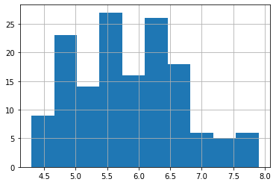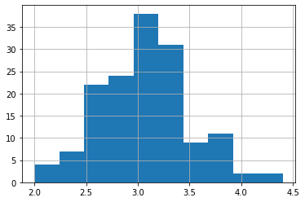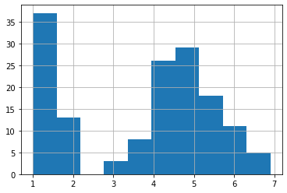

In [39]:

**df['SepalWidthCm'].hist()**

Out [39]: <AxesSubplot:>

In [40]:

**df['PetalLengthCm'].hist()**

Out [40]: <AxesSubplot:>

In [41]:

**df['PetalWidthCm'].hist()**

Out [41]: <AxesSubplot:>

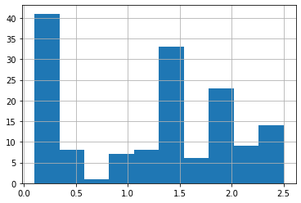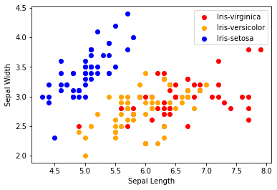

**# Scatterplot**

**colors**

**['red', 'orange', 'blue']**

**species = ['Iris-virginica','Iris-versicolor','Iris-setosa']**

**for i in range(3):**

**x = df[df['Species'] == species[i]] plt.scatter(x['SepalLengthCm'], x['SepalWidthCm'], c**

**plt.xlabel("Sepal Length") plt.ylabel("Sepal Width")**

**plt.legend()**

**co**

**for i in range(3):**

**x = df[df['Species'] == species[i]] plt.scatter(x['PetalLengthCm'], x['PetalWidthCm'], c**

**plt.xlabel("Petal Length") plt.ylabel("Petal Width")**

**plt.legend()**

**co**

In [42]:

**=**

In [43]:

**=**

Out [43]: <matplotlib.legend.Legend at 0x7f0d1374b820>

In [44]:

**=**

Out [44]: <matplotlib.legend.Legend at 0x7f0d1366f070>

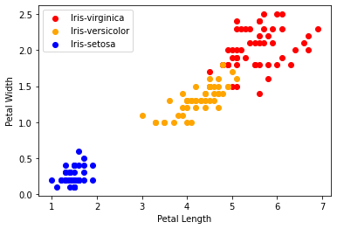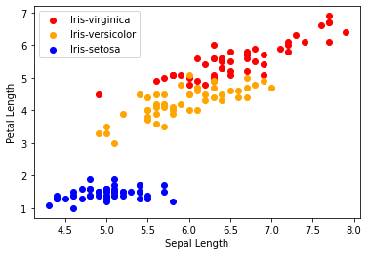

In [45]:

**for i in range(3):**

**x = df[df['Species'] == species[i]] plt.scatter(x['SepalLengthCm'], x['PetalLengthCm'], c = c**

**plt.xlabel("Sepal Length") plt.ylabel("Petal Length") plt.legend()**

Out [45]: <matplotlib.legend.Legend at 0x7f0d135e1130>

In [62]:

**sns.pairplot(df)**

Out [62]: <seaborn.axisgrid.PairGrid at 0x7f0d1394abe0>

|  |  |
| --- | --- |
| **In [46]: df.corr()**  **Out [46]:**  SepalLengthCm SepalWidthCm PetalLengthCm PetalWidthCm | |
|  | SepalLengthCm 1.000000 -0.109369 0.871754 0.817954 |
| SepalWidthCm -0.109369 1.000000 -0.420516 -0.356544 | |
|  | PetalLengthCm 0.871754 -0.420516 1.000000 0.962757 |
| PetalWidthCm 0.817954 -0.356544 0.962757 1.000000  **In [47]: corr = df.corr()**  **fig, ax = plt.subplots(figsize=(5,4)) sns.heatmap(corr, annot=True, ax=ax, cmap = 'coolwarm')**  **Out [47]: <AxesSubplot:>** | |

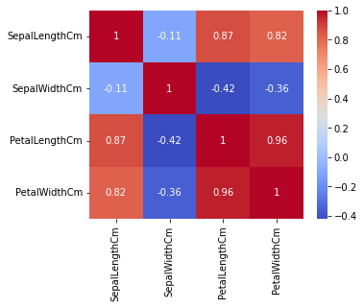

In [48]:

**from sklearn.preprocessing import LabelEncoder le LabelEncoder()**

**=**

In [49]:

**df['Species'] = le.fit_transform(df['Species']) df.head()**

Out [49]:

|  |  |  |  |  |
| --- | --- | --- | --- | --- |
| SepalLengthCm | SepalWidthCm | PetalLengthCm | PetalWidthCm | Species |
| 0 5.1 | 3.5 | 1.4 | 0.2 | 0 |
| 1 4.9 | 3.0 | 1.4 | 0.2 | 0 |
| 2 4.7 | 3.2 | 1.3 | 0.2 | 0 |
| 3 4.6 | 3.1 | 1.5 | 0.2 | 0 |
| 4 5.0 | 3.6 | 1.4 | 0.2 | 0 |

In [50]:

**from sklearn.model_selection import train_test_split # train - 70**

**# test - 30**

**X = df.drop(columns=['Species']) Y = df['Species']**

**x_train, x_test, y_train, y_test train_test_split(X, Y, tes**

**=**

In [54]:

**# knn - k-nearest neighbours**

**from sklearn.neighbors import KNeighborsClassifier model = KNeighborsClassifier()**

In [55]:

**model.fit(x_train, y_train)**

Out [55]: KNeighborsClassifier()

|  |  |  |
| --- | --- | --- |
| **In [56]:** | **# print metric to get performance**  **print("Accuracy: ",model.score(x_test, y_test) * 100)** |  |
| **Accuracy: 95.55555555555556** | | |